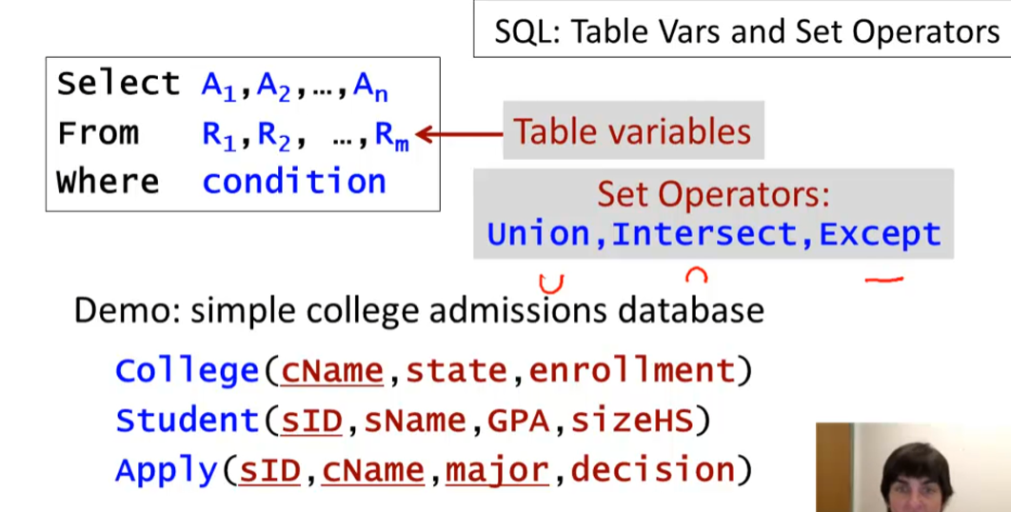

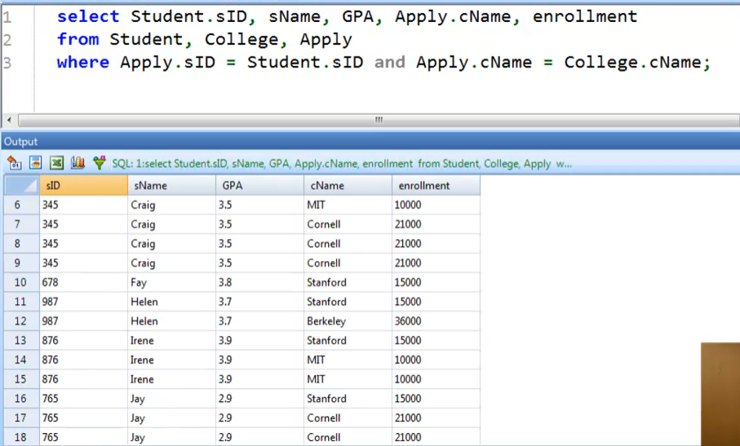

With variables in the tables

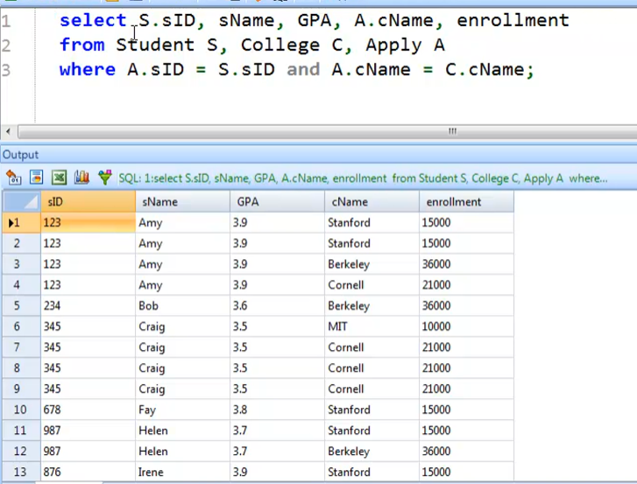

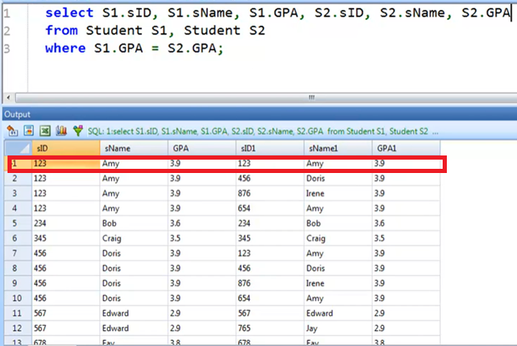

To fix pairing with themselves:

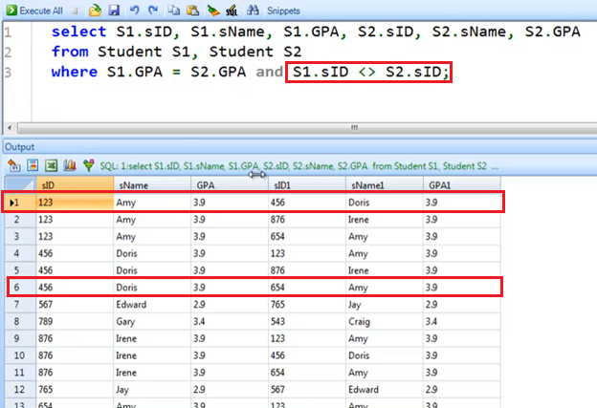

* But we still have redundant pairings

To fix the redundant pairings:

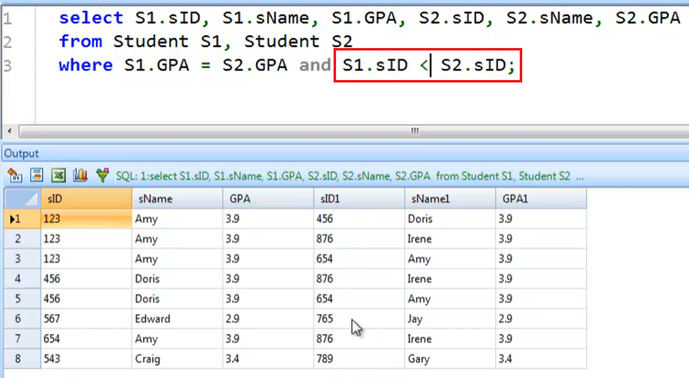

* Smaller SID first

Union Operator

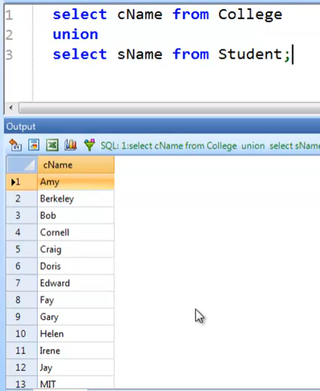

Renaming the result column

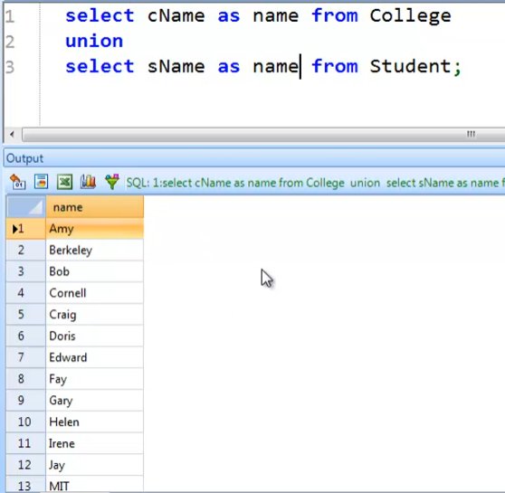

* Eliminates duplicates by **default**!
  + This is the reason why the result looks sorted
  + Because SQLite (DBMS in this example) looks for duplicates by sorting the data
  + It’s not really sorted by default, but it became sorted because of the elimination by default

UNION ALL operator

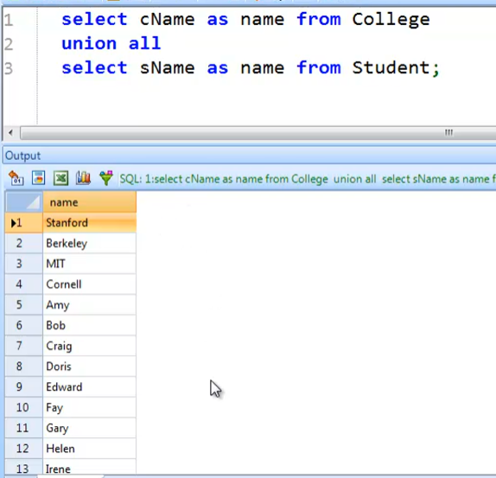

* Unsorted anymore!
* To sort, add order by clause
  + 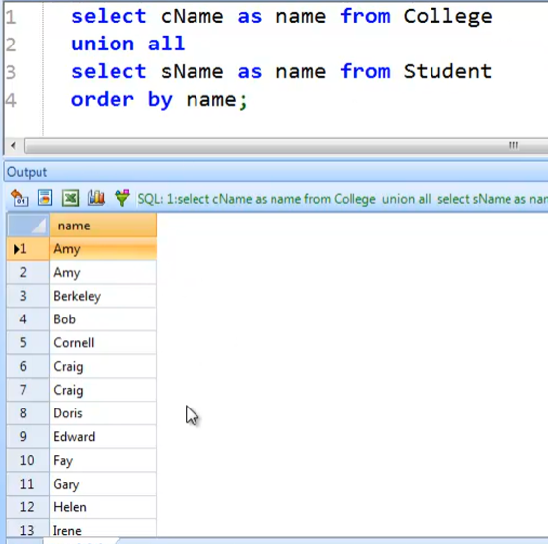

INTERSECT operator

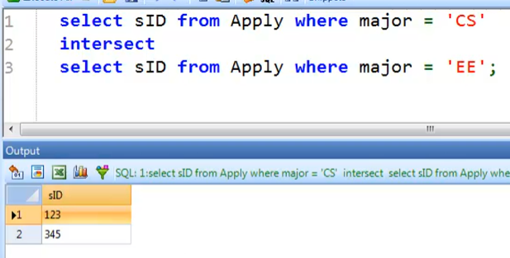

Some DBMS does not support the INTERSECT operator. But we can get the same result using this query:

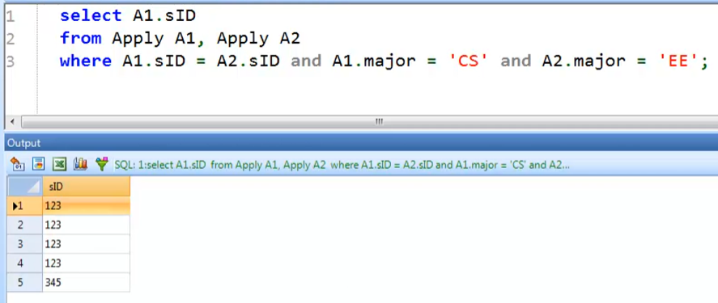

* But this has duplicates!

We just have to add DISTINCT to exactly mirror INTERSECT

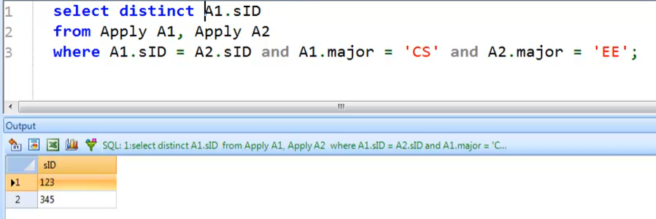

EXCEPT operator

* Difference/minus operator in Relational Algebra

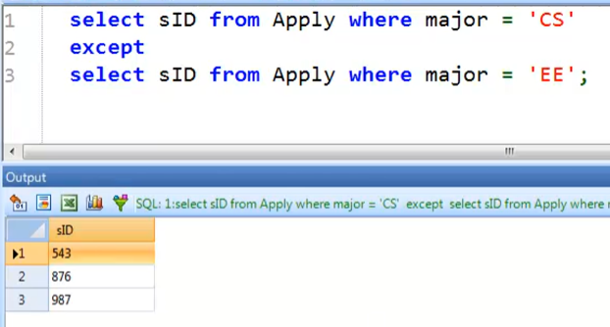

Some DBMS does not support the EXCEPT operator.

First attempt to mirror EXCEPT:

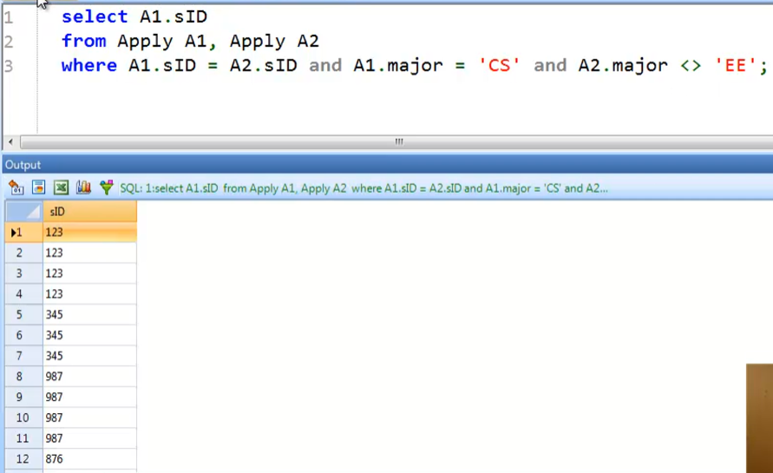

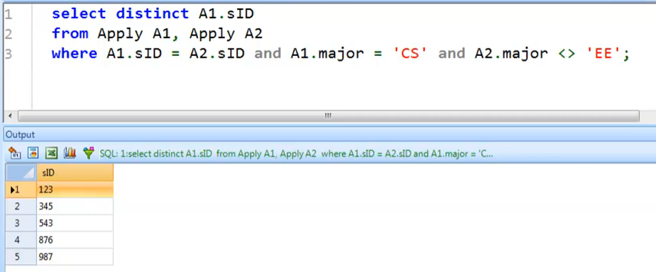

* Not the same!
* We can see in the later lessons on how to mirror it properly!